LE ROUX - Metaplex Candy Machine v2

# **1.Getting Started**

git clone <https://github.com/metaplex-foundation/metaplex.git>

npm i –global yarn

npm i –global typescript

npm i –global ts-node

En étant dans metaplex/js

yarn install



ts-node ./packages/cli/src/candy-machine-v2-cli.ts --version



On installe solana avec les commandes ci-dessous:

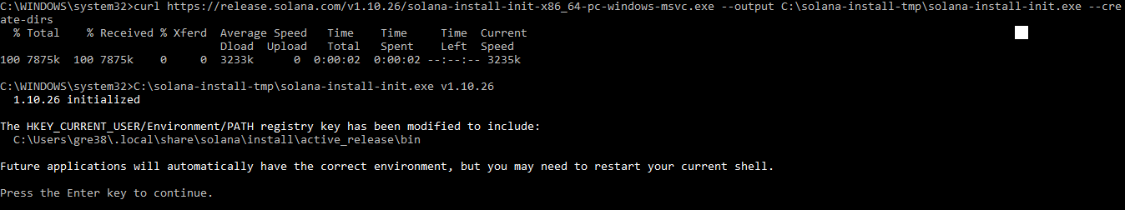

solana –version



solana address

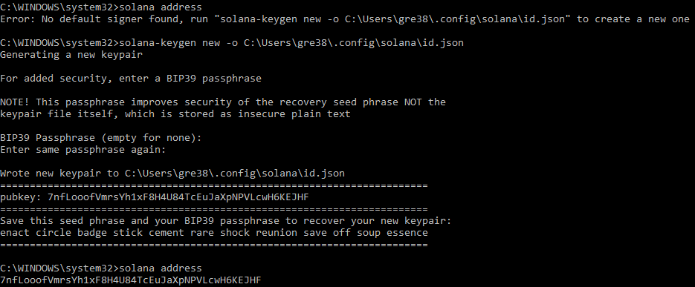

solana balance



### **Setting up a devnet wallet (for testing)**

On config notre key devnet avec les commandes suivantes :

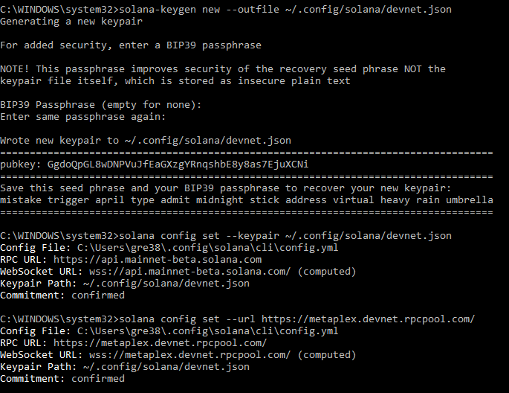

Et notre config correspond à cela :

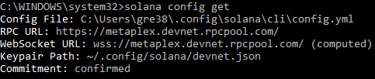

solana airdrop 2

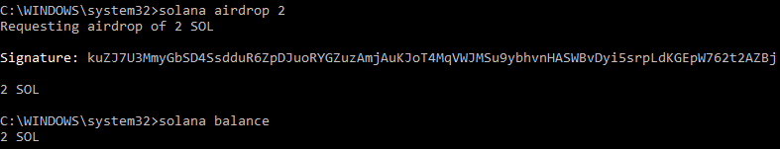

# **3.Preparing your Assets**

Ajout et vérification des assets

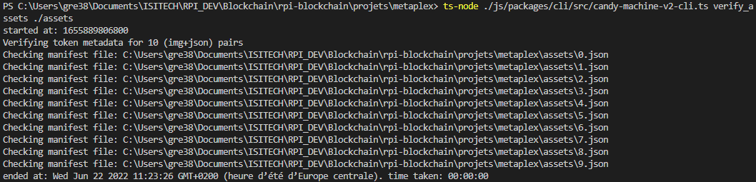

# **4.Creating the Candy Machine**

ts-node C:\Users\gre38\Documents\ISITECH\RPI_DEV\Blockchain\rpi-blockchain\projets\metaplex\js\packages\cli\src\candy-machine-v2-cli.ts upload -e devnet -k C:\Users\gre38\~\.config\solana\devnet.json -cp C:\Users\gre38\Documents\ISITECH\RPI_DEV\Blockchain\rpi-blockchain\projets\metaplex\js\packages\cli\config.json C:\Users\gre38\Documents\ISITECH\RPI_DEV\Blockchain\rpi-blockchain\projets\metaplex\assets

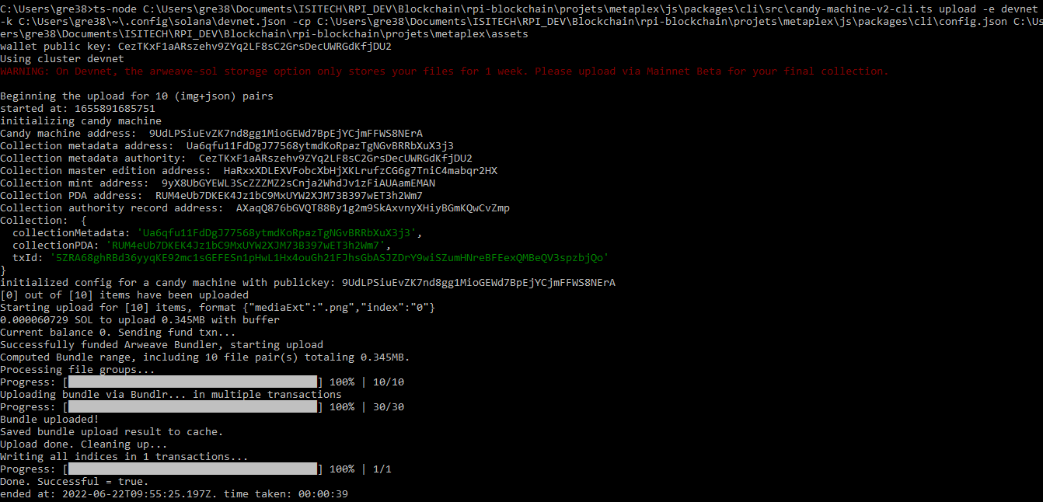

# **5.Verify Upload**

ts-node C:\Users\gre38\Documents\ISITECH\RPI_DEV\Blockchain\rpi-blockchain\projets\metaplex\js\packages\cli\src\candy-machine-v2-cli.ts verify_upload -e devnet C:\Users\gre38\~\.config\solana\devnet.json

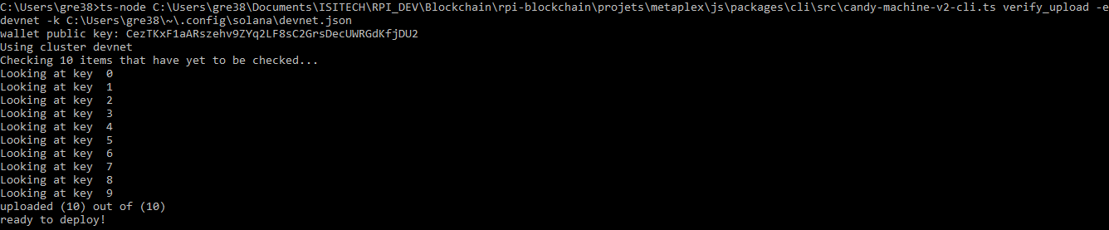

# **6.Mint Tokens**

Mint One Token

ts-node C:\Users\gre38\Documents\ISITECH\RPI_DEV\Blockchain\rpi-blockchain\projets\metaplex\js\packages\cli\src\candy-machine-v2-cli.ts mint_one_token -e devnet -k C:\Users\gre38\~\.config\solana\devnet.json



Check mint was successful with : spl-token accounts

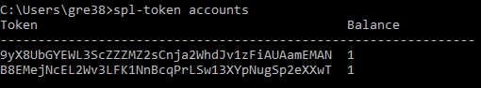

Mint multiple tokens

ts-node C:\Users\gre38\Documents\ISITECH\RPI_DEV\Blockchain\rpi-blockchain\projets\metaplex\js\packages\cli\src\candy-machine-v2-cli.ts mint_multiple_tokens -e devnet -k C:\Users\gre38\~\.config\solana\devnet.json --number 2

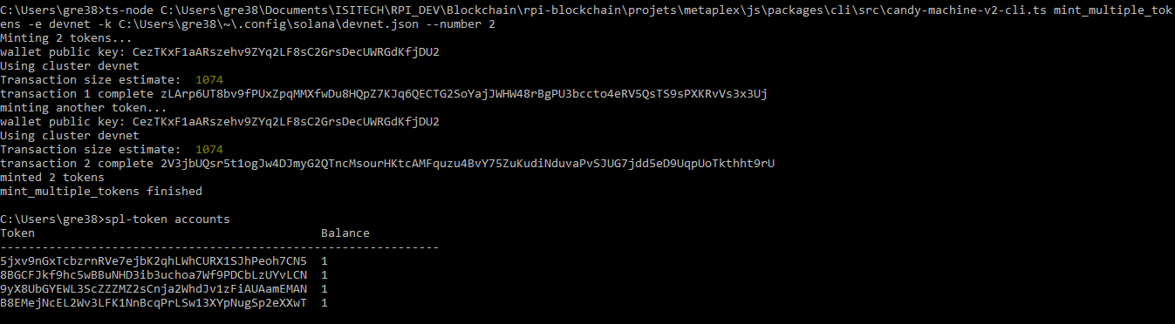

# **7.A Front End Minting Experience**

We need to change env.example located in the folder ~/metaplex/js/packages/candy-machine-ui

REACT_APP_CANDY_MACHINE_ID=<YOUR CANDY MACHINE PROGRAM ID>

Then we change .env.example to .env and we do *yarn install* and *yarn start,* finally we have this screen : 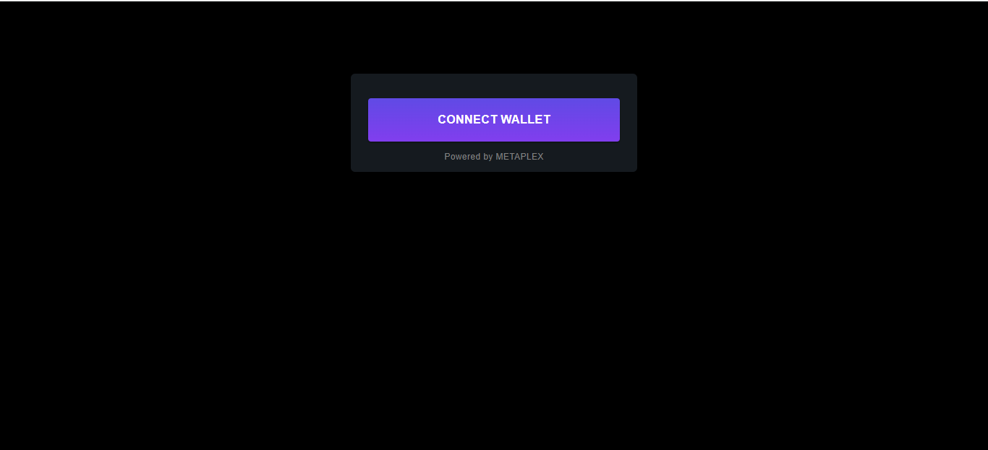

And we have this screen when we try to mint :

